Physics 202  February 8, 2007 | Name:

Capacitors.

1. Simulation of RC Circuits

Build the circuit shown below. The capacitor can be found next to the resistors under the Basic button. The switch can be found under the Basic button as well. The oscilloscope can be found on the far right.

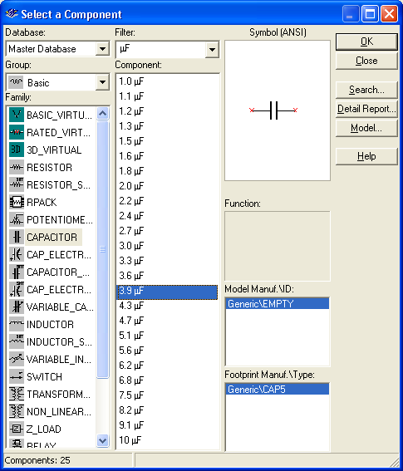
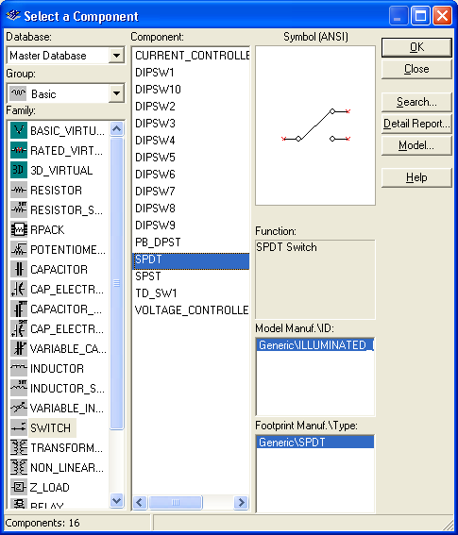
Open up the oscilloscope (right click) so that the display shows. Activate the simulation and flip the switch so that the capacitor is charging. Then when the capacitor is almost fully charged flip the switch so that it discharges. Let it (almost) fully discharge and stop the simulation. Expand the oscilloscope and adjust the time base and number of volts per division so that most of the charging curve can be seen as shown below. Adjust the cyan (1) and yellow (2) cursors such that the cyan cursor is at the edge of where the charging begins and the yellow cursor is at 63% percent of the saturation voltage (the saturation voltage is 5V in this case). Recall that the time constant is the time for the charge to reach about 63% of its saturation value. Vary the resistance and collect data to fill in the tables that follow.

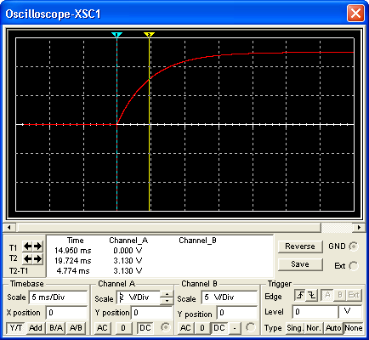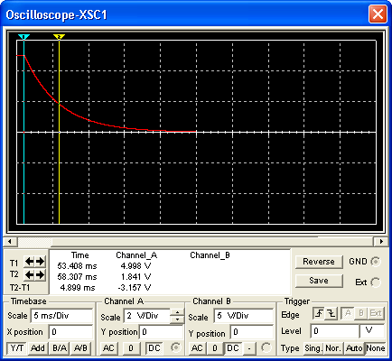

R=1.24 kΩ C=3.9μF
Voltage  applied (V) | 63% of Voltage (V) | Time to charge to 63% (s) | 37% of Voltage (V) | Time to discharge to 37% (s)
5
10
15
20

Are the charging times and discharging times equal?

Are the times the same for different applied voltages?

For one of the discharging parts of the oscilloscope reading, find the voltages for ten different times.

Time ( ) | Voltage ( )

Make a plot of this data in Excel and fit it to an Exponential. Paste the graph below.

What is the time constant from the Excel plot? How does it compare to the results obtained above?

Repeat the original type of measurements above, but change the resistance.

Charging Part with Capacitance C=3.9μF and Voltage=5V
Resistance (kΩ ) | Start Time ( ) | 63% Time ( ) | Time constant ( )
1.24
2.05
3.3
4.3
5.1

Use Excel to make a plot of Charging Time Constant versus Resistance. Paste it into this document.

Next examine the discharging portion of the circuit. Locate the time where the discharging begins and where the voltage is 37% of that at the beginning of the discharging.

Discharging Part with Capacitance C=3.9μF and Voltage=5V
Resistance (kΩ ) | Start Time ( ) | 37% Time ( ) | Time constant ( )
1.24
2.05
3.3
4.3
5.1

Make another Excel plot of Discharging Time Constant versus Resistance. Paste it into this document.

Is there any difference in the charging time’s dependence on resistance and discharging time’s dependence on resistance?

Repeat the procedure, but now vary the capacitance.

Charging with Resistance 1.24 kΩ and Voltage=5V
Capacitance (μF) | Start Time ( ) | 63% Time ( ) | Time constant ( )
1.2
2.2
3.9
5.6
8.2

Make a plot of Charging Time Constant versus Capacitance. Paste it into this document.

Discharging with Resistance 1.24 kΩ and Voltage=5V
Capacitance ( ) | Start Time ( ) | 37% Time ( ) | Time constant ( )
1.2
2.2
3.9
5.6
8.2

Make a plot of Discharging Time Constant versus Capacitance. Paste it into this document.

Is there any difference in the charging time’s dependence on capacitance and discharging time’s dependence on capacitance?

2. Equivalent capacitance.

Simulate the circuit below.

What is the time constant for the circuit? Paste a screen capture of the oscilloscope displaying your result.

Does this agree with the theory for combining capacitors? Explain.

Simulate the circuit below.

What is the time constant for the circuit? Paste a screen capture of the oscilloscope displaying your result.

Does this agree with the theory for combining capacitors? Explain.

What is the equivalent capacitance of the circuit shown above?

What is the net charge expected to come out of the battery and be placed on the capacitors?

What is the charge on each capacitor?

3.0 μF:
4.3 μF:
2.2 μF:
5.1 μF:
1.5 μF:

3. RC circuits with combinations

Use theory to predict the charging and discharging times of the circuit shown below. You must give your reasoning in detail. Then attach an oscilloscope to the circuit and take measurements to verify your prediction. Paste a screen capture showing the oscilloscope read out (with numbers) for both the charging and discharging scenarios.

Reasoning:

 | Charging Time ( ) | Discharging Time ( )
Prediction
Simulation

